**Setting up GIT CI for hello-world-war project:**

Step1: Clone the hello-world-war to your github repo.

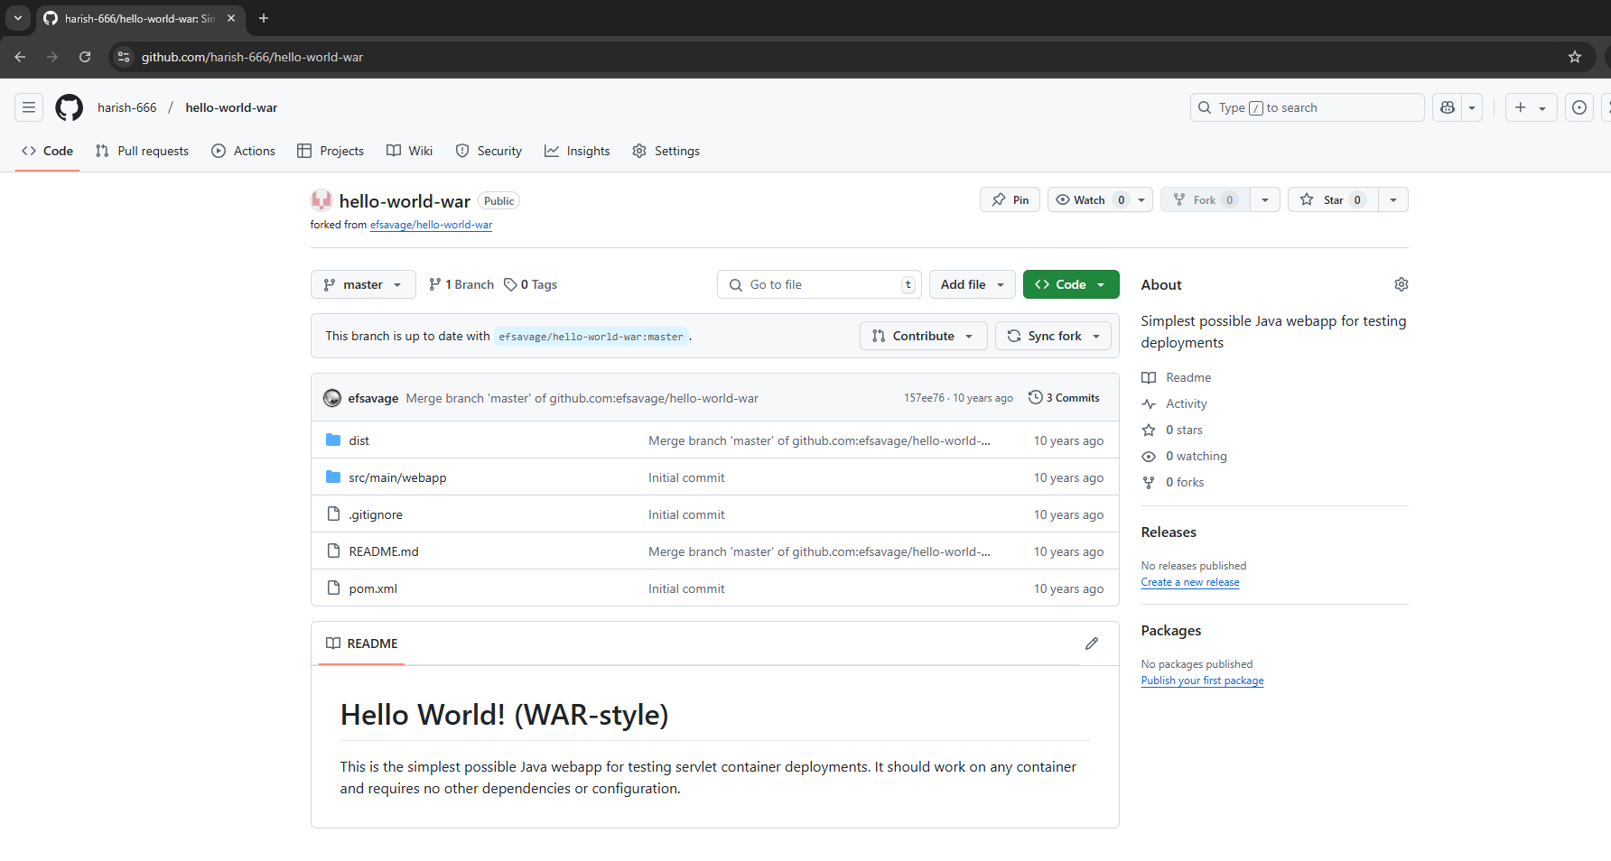

Step 2: Go to Actions tab and select Java with Maven Github action.

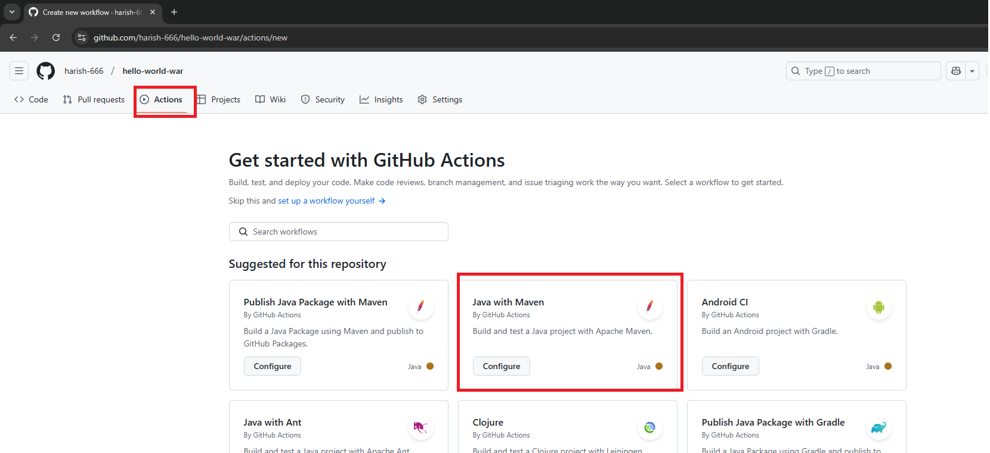

Step3: This generates a yml file, inside .github/workflows directory.

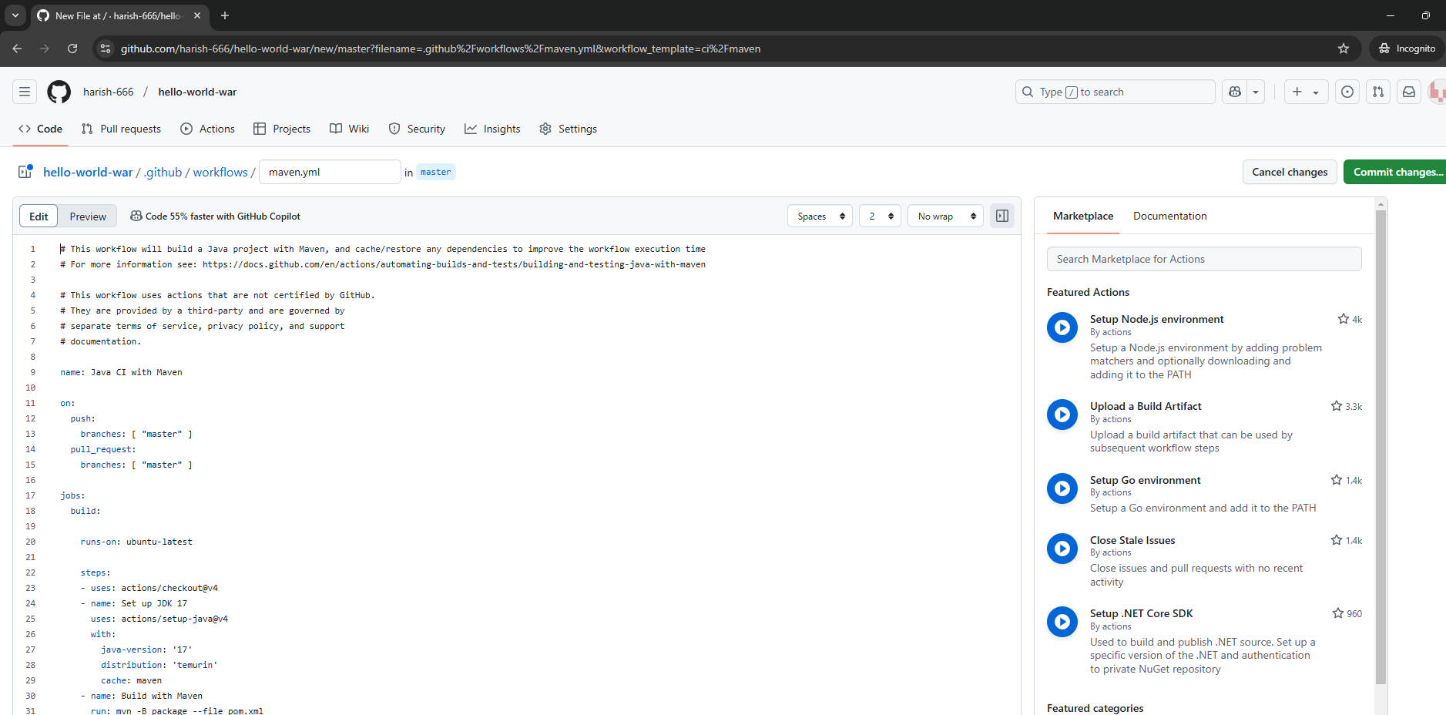

Replace the maven.yaml file content with the below content:

Note: yaml is a mark up language similar to xml, hence the tab spacing here is important. It won’t work if the spacing is not proper.

# This workflow will build a package using Maven and then publish it to GitHub packages when a release is created

# For more information see: https://github.com/actions/setup-java/blob/main/docs/advanced-usage.md#apache-maven-with-a-settings-path

name: Build, Deploy, and Upload Artifacts

on:

push:

branches:

- '**'

pull_request:

branches:

- master

workflow_dispatch:

jobs:

build:

runs-on: ubuntu-latest

steps:

# Checkout the repository

- name: Checkout Code

uses: actions/checkout@v3

# Set up Java

- name: Set up Java

uses: actions/setup-java@v3

with:

java-version: '11'

distribution: 'temurin'

# Cache Maven dependencies

- name: Cache Maven dependencies

uses: actions/cache@v3

with:

path: ~/.m2

key: ${{ runner.os }}-maven-${{ hashFiles('**/pom.xml') }}

restore-keys:

# Build the project with Maven

- name: Build with Maven

run: mvn clean install

Save and commit the file:

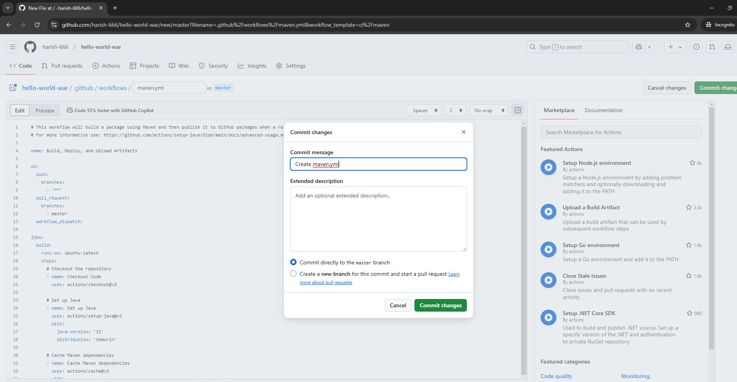

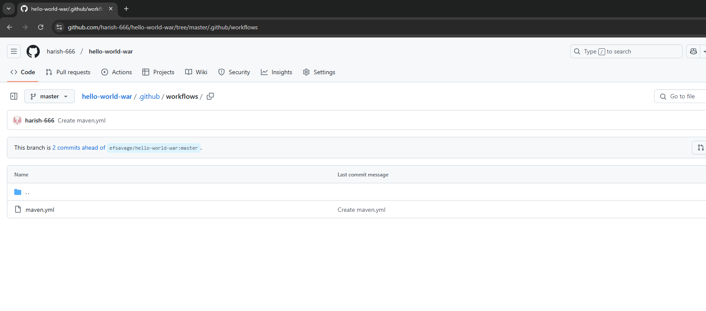

Once you commit the file, go back to Actions tab and it would have started the build process.

Similar to the one we saw in jenkins. Click on the workflow below to open it.

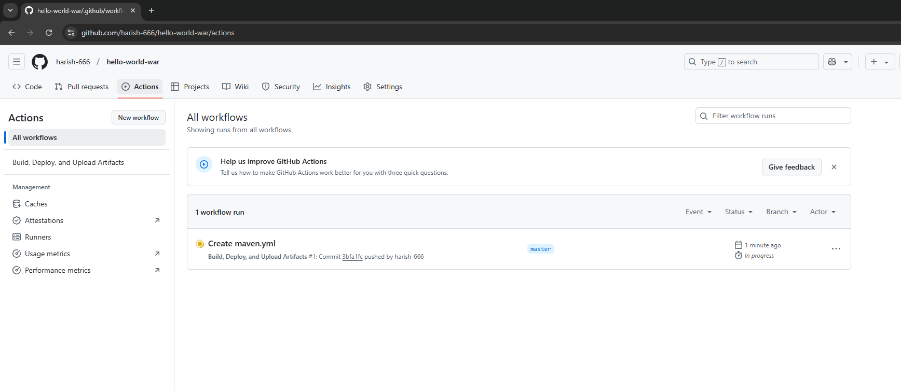

You can click on the build button below again to see the steps:

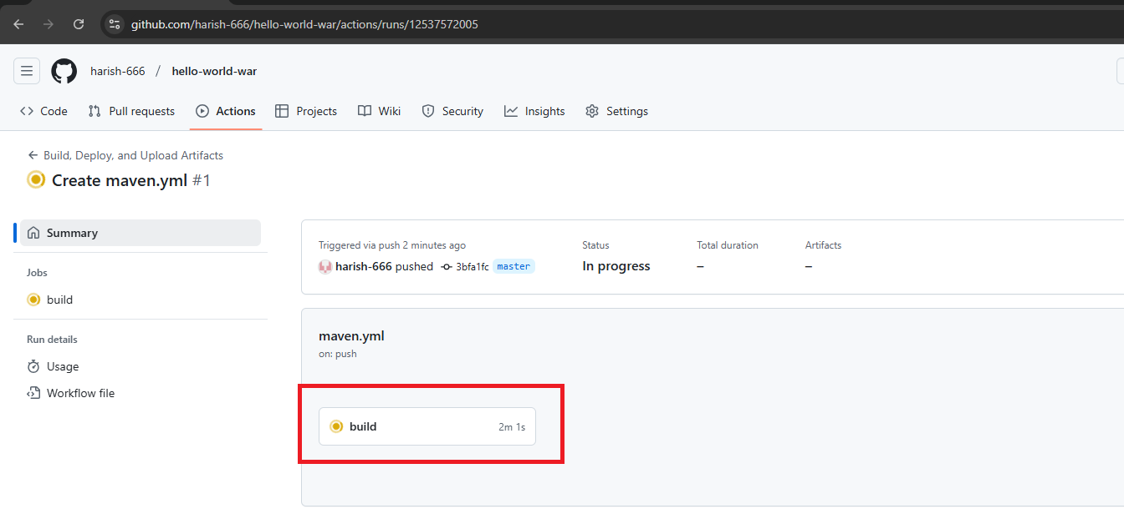

It will have all the steps mentioned in it and you can see the war file created.

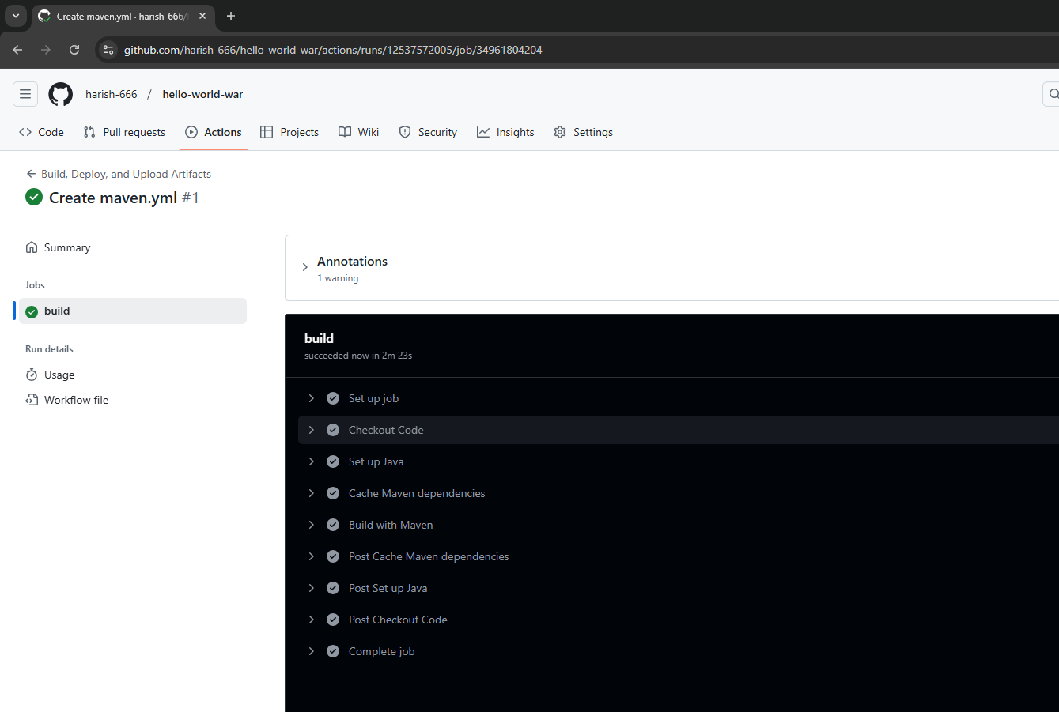

You can see the war file in this step: target/hello-world-war-1.0.0.war

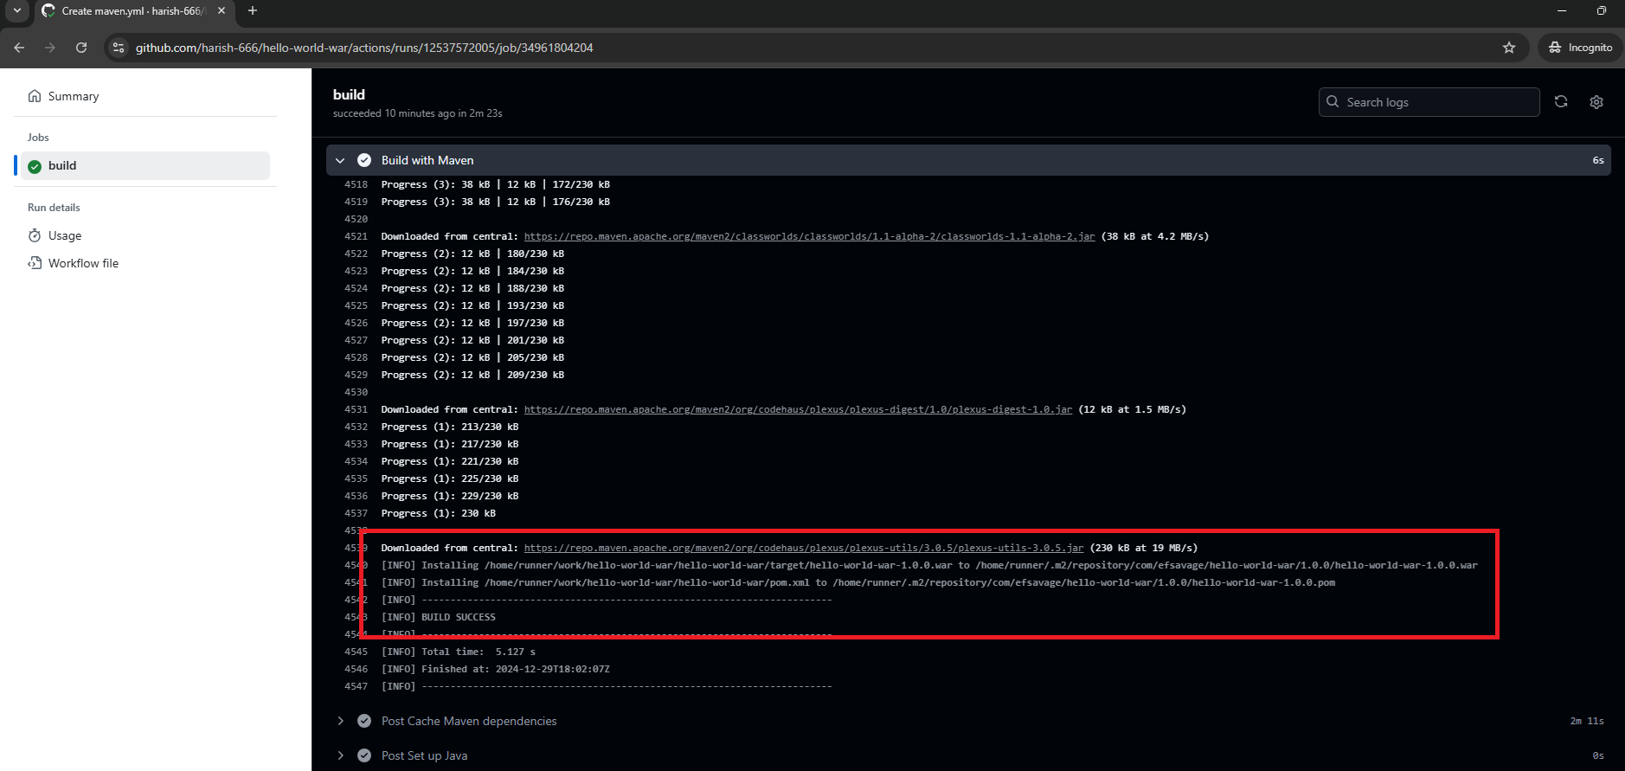

Runners: These builds runs using github’s default ubuntu instances, we can see them by clicking in runners button below.

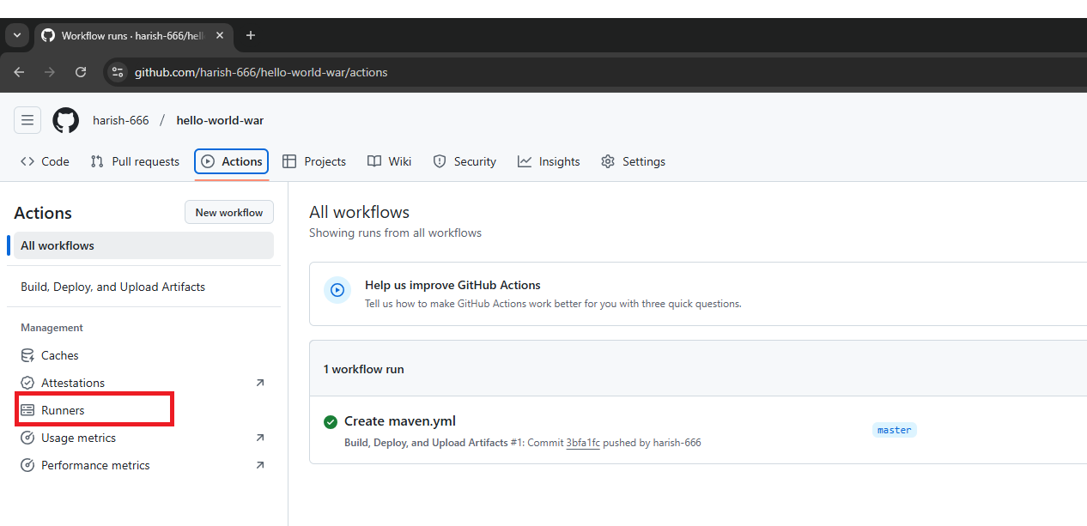

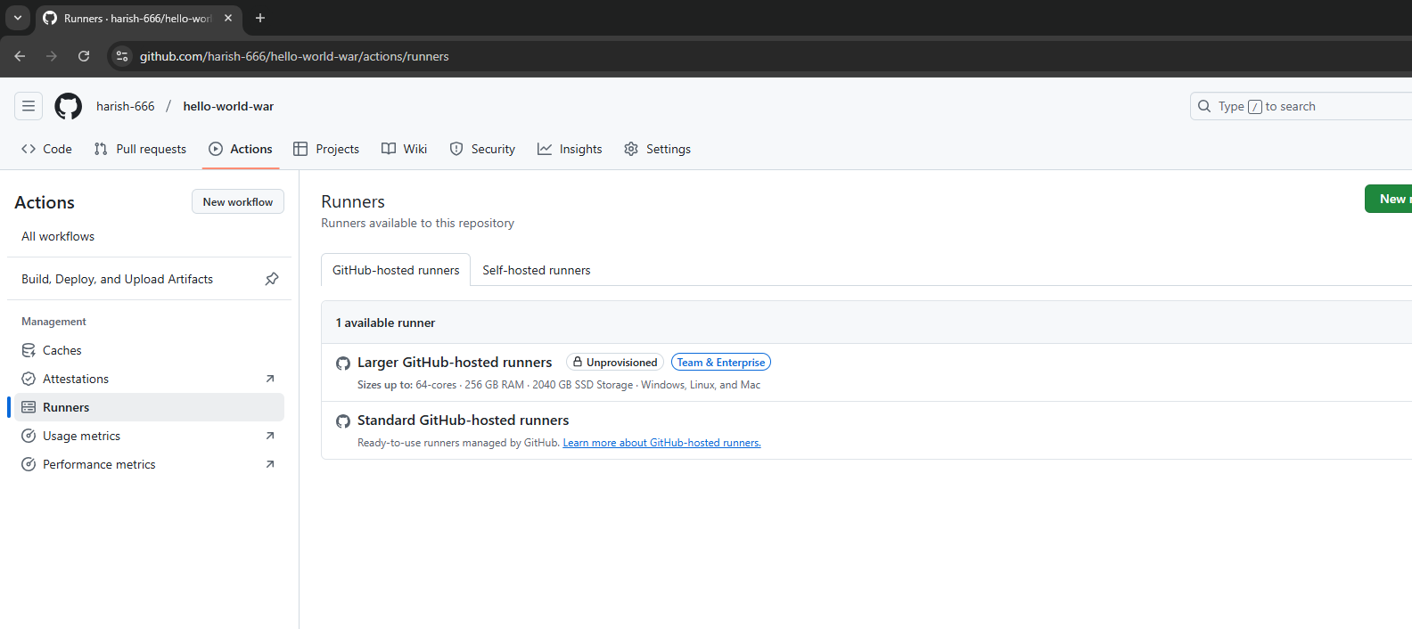

We can connect an EC2 ubuntu instance as a runner by selecting self-hosted runners here. (Optional)

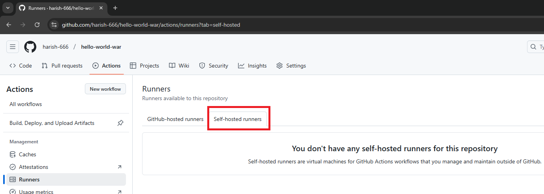

Click on new runner and follow all the steps:

